http://www.webganges.com

**2011**

Company Profile



Address:- 11, Neelkanth Market Ramadevi Chauraha, Kanpur - 208007 (U.P) – INDIA

Mob:- +91 - 84000 - 84111

+91 - 9235 237 376

Email:- [info@webganges.com](mailto:info@webganges.com)

<URL:-> www.webganges.com

www.webgangesedu.com



Introduction

About Us

**WebGanges Technologies Pvt. Ltd.** is a Web Design & Development company. The company offers corporate identity design services, affordable offshore website design and development, e-commerce web design.To view some of our Website Development and Website Design work have been successfully designing and developing Web Design solutions for a range of global organizations . Each design solution is unique in terms of organizational learning and delivering the solution to the desired standards. Over the years we have designed more than hundreds of web pages.  
  
**WebGanges** is the specialists for affordable Search Engine Optimization Services in India and deliver the best services for Search Engine Optimization in India.  
  
**WebGanges** provides Interactive presentation tools using animations, rendered graphics and audio/video coverage, all produced indigenously and synthesized into a comprehensive package which can be presented using media like CD ROM / DVD or streaming over the web. On several occasions getting a Perfect solution within the time, budget and specifications could be an up-heal task for you. Sometimes you may not be very sure of the starting point. That’s exactly when we come into the scenario and deliver the solution which will match all your needs based on the variety of Business Functions. We firmly believe that our experience will help you achieve the job done in most optimum manner.

What the Company does?

Leading Information Technology(IT) company based in Kanpur, India. **WebGanges** is a Private Limited Company dedicated to provide the best solution in the IT industry. It is established in the year 2010 in Kanpur at Gandhi Gram.   
We cater and collaborate with a wide client base and business partners and offer a galore of services relating to all the sectors in the IT industry. **WebGanges** specializes in Online and Offline Software development which are broadly classified according to customer requirements . From retail billing software to retail automation, secure web applications, E-commerce, portal application development to corporate website design to high end websites. We bundle our services with Hosting Services and Secure E-mail solutions, Internet Marketing program with SEO services for our customers in India and Abroad. **WebGanges** also provide Bulk SMS services for both Online and Offline clients.

**WebGanges** has launched a project **WebGangesedu** – An IT Institute for imparting knowledge of latest technologies to the students of different fields B.Sc., BCA, B.E, B.Tech., MCA, that will provide good placement in top MNC’s and other IT companies and sectors.

Strategy

Vision

**WebGangesedu** has a clear vision to create a chain of software training centers across the globe with innovative teaching method and world class infrastructure. Each center should be equipped with state of the art infrastructure, professional management and friendly culture.

Our social vision for our Company is that we would like to bridge the gap of demand and supply for Trained IT professionals. Training students on what is needed by industry and providing candidates to industry of their required skills.

Mission

To Become Leaders in Providing Quality Services at Competitive Prices while ensuring timely delivery to our clients/customers.

**WebGangesedu** believes in making the training process acceptable and accessible to all level of students. Our mission to run an IT software training institute is to make candidates employable in IT industry. With all our processes, hard work, infrastructure and trained staff, our effort is to make each and every student grab the IT opportunities in the market.

Business Goals and Objective

* We make you come on top of search engine ratings because our web content is search engine optimized.
* Our graphics designers are there to get you more return visitors and not put them off forever with bulky images that take forever to download.
* We make sure the info on your site is accurate and readable.
* Our websites are java integrated.
* We test and evaluate the website, and do constant debugging until it runs perfectly. Visitors and users alike will not have any problems browsing through the websites we develop.

Our Team

**WebGanges** is backed by a team of committed, experienced and qualified professionals. The team is the firm's biggest asset. Unlike Industry standards, **WebGanges** has a retention rate of 75% for its employees which in turn imply very highownership standards. Our team comprises of specialists from the following areas:   
  
Software Professional with Master’s/Bachelor Degree in Computer Application with having skills in C#.Net, ASP.Net, Java, Java Script, Oracle 9i, and PHP etc. Software Engineering Graduates in Information Technology having experience in C#, Dot Net, PHP Science Graduates qualified in “2D/3D” Animation, flash and graphic designer. Web development projects to enhance marketability of products by making proper presentation.

Our Capabilities **Our Technical Strengths:**Our strength is in recognizing client needs and fostering an on-going relationship from initial contact to follow-up support. Keeping just the right balance of your industrial experience and our tech minds, our projects transform into long-term partnerships from day one. We go beyond collecting 'done it' certificates!!

Business Concepts

Quality Policy

To provide highest quality of software development solution and services that will put our clients business on the cutting edge all over the world and to enhance their satisfaction by continual improvement of our systems.

Our Services

The company’s service portfolio includes customer requirement study, formulating specs, designing, developing, quality assurance, benchmarking, documenting, implementing, integrating, training, maintaining and providing online support. You are totally relieved of interacting with different parties for different components. We are primed to provide our esteemed clients with top-class functional and technical services in all areas of IT like:

* Website Designing & Development
* Static Website
* Dynamic Website
* E-Commerce Website
* Flash Website
* Software Development
* Graphics Designing
* Domain Registration & Web Hosting
* Search Engine Optimization
* Ad Posting & Bulk SMS
* Professional Training
* (C#, ASP.NET, PHP, SEO, Web Designing)

Project Methodology

We follow a comprehensive software development life cycle for our clients. The dynamic nature of Internet business is mirrored in special challenges in the development cycle of enterprise applications, consisting of requirement capture & study, spec, design, development, quality assurance, benchmarking, documentation, maintenance and online support. At all stages in the project cycle, it is necessary to be battle-ready for change of plans. Thus it is necessary to maintain effective communication with the customer for status updates, feedback elicitation and

approvals. Our time-tested project management methodology is optimized for tackling these challenges effectively.



**We are cut above others in view of the fact that:**

* + Our versatility means that our customers can gain the well-known advantages of offshore in virtually any job required by them.
  + Our Offshore Development Center quickly and cost effectively help you to attain the goal by functioning as an extension of your in-house software development capabilities. We have a well-honed control and coordination mechanisms to ensure that we effectively function to address your requirements, while seamlessly integrating with your vision and goals for providing you with the ability to quickly respond to the changing business environment.
  + We meet our clients personally & periodically and outsource our team members to client site if required.
  + Our service group works on-site to manage and execute the implementation of customer process management applications efficiently and economically.
  + We have strict internal guidelines that all our programmers are required to follow.
  + Through rapid process modeling, business processes are optimized to eliminate unnecessary tasks, and streamlined to include process steps necessary to achieve the desired results.
  + Detailed data needs analysis ensures that the appropriate information necessary to accelerate the business process is captured, managed, and distributed to people when and where it is needed.
  + Quality and Reliability being our mission, we do everything possible to ensure that the client gets bug free software.
  + Our documentation standards are of the highest quality. All the documentation we generate is HTML based so that you can easily publish it on your intranet.
  + Effective measurement and feedback systems to capture and report performance information.
  + Constant Progress reports and updates are given to our client from time to time.
  + Our approach is to use the Internet and Intranet technology as the collaboration platform, since this gives pervasive access.
  + We provide support for our software for an agreed timeframe and long-term support is provided under the maintenance contract.

**Our Skills**

|  |  |  |  |  |  |  |  |  |  |  |  |  |  |  |  |  |
| --- | --- | --- | --- | --- | --- | --- | --- | --- | --- | --- | --- | --- | --- | --- | --- | --- |
| |  |  | | --- | --- | | **Programming Languages** | **Web Tools** | | **C, C++, C#,**  **C#.NET, VB.NET,**  **PHP, ASP.NET, Java Enterprises – GWT Web Application Development, Android Application, SEO, etc.** | **HTML, DHTML,**  **XML, XSL, XHTML,**  **Ajax, Java Script, J-Query, CSS** | | **Databases** | **Platform** | | **SQL Server - 2000/2005/2008,**  **SQL Server - Express Edition,**  **My SQL, Oracle- 8i/9i** | **Windows 2000/2003/XP/7/8** | | **Application Web Server** | **Programming Tools** | | **Microsoft IIS,**  **Apache, XAMP Server, Apache Tomcat,**  **Oracle Application Server** | **Visual Studio - 2008/2010/12,**  **Dream Weaver - 8/CS4** | | **Reports** | **Designing Tools** | | **Crystal Reports** | **Corel Draw – 8/CS3/CS4, Adobe Illustrator**  **Adobe Photoshop -CS4,** **Adobe Flash** | |

WebGangesedu Catalogue/ Course Structure

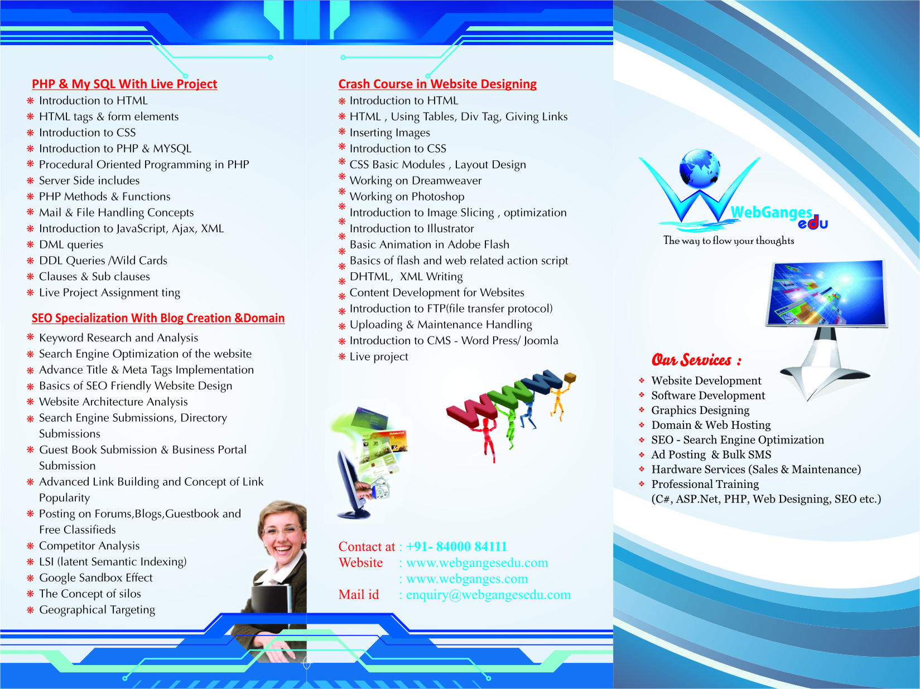

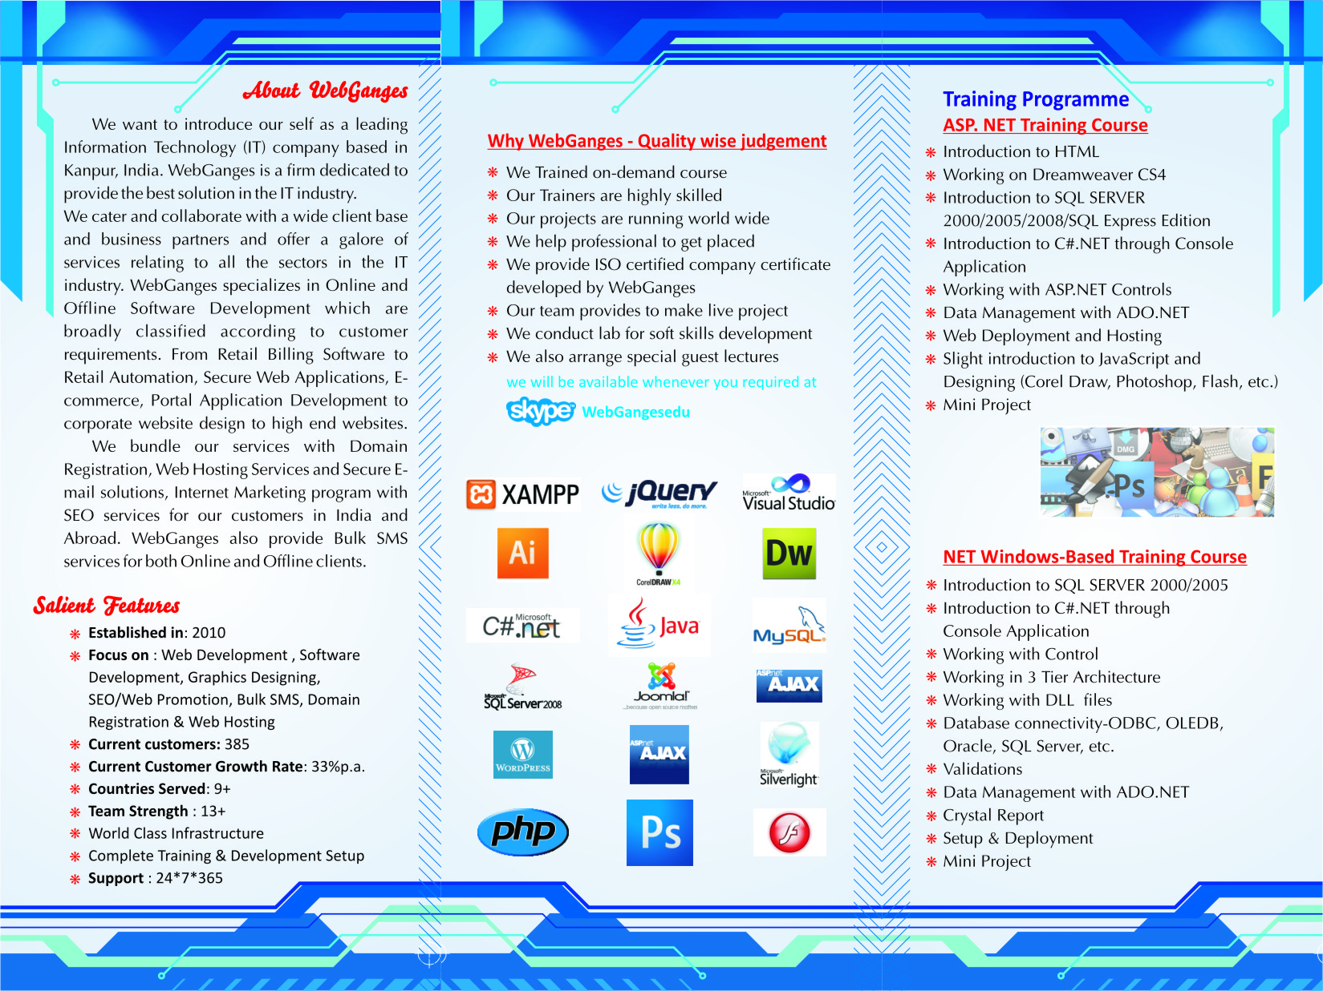

Current Customers & Projects

* Village –X- Technology , Barabanki – INDIA
* Carton- Tech , Saudi Arab
* BlackDiamond Survey , Harayana - INDIA
* Silicon- Tech, Kanpur - INDIA
* Eden Green City , Lucknow – INDIA
* Exclara – USA
* Ashish Group , Kanpur – INDIA
* RU Advance Advertisers , Kanpur – INDIA
* Hotel Gagan Plaza , Kanpur – INDIA
* Hotel Nirmal Palace, Kanpur – INDIA
* Nini Aquariums , Kanpur – INDIA
* Eyes of Nation , Lucknow – INDIA
* Khan Matrimonials , Allahabad – INDIA
* STC Paras , Kanpur – INDIA
* Inaya Footwear , Unnao – INDIA
* Print Media , Noida – INDIA
* Scope Services , Lucknow – INDIA
* PNS Media , Lucknow - INDIA

Institutional Clients

* NIHT- National Institute of Hardware & Technology , Lucknow - INDIA
* International School of Business Management & Studies , INDIA
* Future Net , Unnao – INDIA
* Kautilya Study Circle , Kanpur – INDIA
* Anish Srivastawa IIT Physics Coaching , Kanpur - INDIA
* Babol & Shani IIT Coaching , Kanpur - INDIA
* Sai Academy , Kanpur - INDIA
* Historica Vision , Kanpur – INDIA
* National Institute of VAMAS – Kanpur – INDIA
* New Kingston Academy , Kanpur - INDIA
* Takshilla International Education Center , Kanpur – INDIA
* Gaurav Memorial International School, Kanpur – INDIA
* Lords Computer Institute , Kanpur - INDIA
* Data Expert Computer Institute , Kanpur - INDIA

NGO Client’s

* Parad Shivlingam , Allahabad – INDIA
* Amarnath Sewa Mandal, Harayana – INDIA
* Bhakti Bhaw , Hyderabad – INDIA
* Panditji Namaste , Kanpur - INDIA
* Vaidik Dham , Kanpur – INDIA
* Sri Aduat Paramhans Dayal Samiti , Noida - Kanpur

Route Map

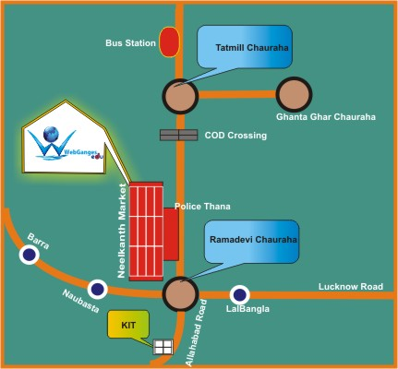

**Contact Us**

WebGanges

Address:- 11, Neelkanth Market, Ramadevi

Chauraha ,Kanpur (U.P) – INDIA

Mob:- +91- 84000 84111

+91- 9235 237 376

Mail :- [info@webganges.com](mailto:info@webganges.com)

Web:- [www.webganges.com](http://www.webganges.com)

www.webgangesedu.com